Chapter 1

***INTRODUCTION***

# INTRODUCTION

This application will track time and show you notification after a brief period of time to remind you one English word+ Pronunciation + Meaning in Marathi. We are use plyer module to show the notification and the time module to run the module after a fixed period of time. We can install plyer by typing “pip install plyer” on the terminal/cmd. We are going to implement our own Reminder application with notification for desktop. Reminder application is a very simple application for pc and probably everyone has used this application at-least one time you learn one new English word with Pronunciation +Meaning in Marathi. In this tutorial, we will create a simple Reminder application with notification. Reminder apps (applications) have played an important role in my life by supporting my academic career.

The choices people have for spending time and the multiple pressures on time have increased the interest in tools for helping people to improving learning skills. First step we discussed on our chosen project topic, and then we researched on topic. After that starting worked on our project idea. Then we imported the packages in python for the reminder application. Then we installed plyer for notification and import time. We added some English words + Pronunciation +Meaning in Marathi.

English too many people, is the easy major. However, it is not easy. Writing analyzing reading and all the other skills that we utilize every day are not easy. That think getting a job with an English degree is impossible and ignorant people think you can only teach with your degree Improve productivity and quality of works. This application spoken easy pronunciation of the remainder in Marathi and in English language. You can also modify the reminder's notification time list that it belongs to. Today shows all of your

Reminders that you marked as being due today. It also shows reminders that are overdue. All shows every reminder, organized by notification bar on desktop.

I have referred many sites but still I am not able to create the notification (reminder or alarm) I don't know exactly how to create and work with it. It’s to notify/remind user about task and also provide daily words to the user. I will be glad to have your help in doing so and how to code it too.

There were no reminder apps for the word a few years ago but there are some apps like alarm notifications to wake up using time. Watering applications to remember to drink water. Based on that, we created word reminder applications for words on the desktop, also created some applications and programs to remember some of those birthdays.

The rest are very difficult to translate from English to those who do not speak English. Many websites offer English translation services for a few dollars. It's a good idea to translate a lot of text (like books, articles) and pay for professional services, but it doesn't make sense to pay for commonly used words, greeting messages and other informal use. For these purposes, this tool can be used.

I have referred many sites but still I am not able to create the notification (reminder or alarm) I don't know exactly how to create and work with it. It’s to notify/remind user about task and also provide daily words to the user. I will be glad to have your help in doing so and how to code it too.

## 1.3 Importance of Project Area

**Time saving: -**using computers can save a lot of time. This is possible, as computers are fast, efficient and more accurate as compared to human beings.

**Efficient and accurate: -**computerization will increase the efficiency and accuracy of the telephone department in maintains telephone directory.

**Faster and easier data retrieval: -**by using computerized system data can be retrieved at much faster pace. Old records can be located immediately and easily.

## Problem Identification

* + - In an existing system, all the process is done manually. This is time consuming System. This process is difficult because of a day the people are increases.
    - There are some Application provided for reminder or alarm provides online service.

## Advantages of Proposed System

* Standalone application.
* The aim of the proposed system is to develop a system with improved knowledge about English word with their pronunciation also meaning in Marathi.
* Our application saves the time of user and display result quickly after correct time.
* Easy to understand :
* Multitasking: It is multitasking because we can work on multiple windows at a same time and at that time we get notification without closing our current window.
* Maintain our time.
* Will increase efficiency.
* It will help students, by saving extra time.
* Easy to use: Easy to use because application does not need any other server or database to make connectivity of that code and words.
* It helps to recall our knowledge about English word with the help of notification.
* User get notification as time fixed in code.
* Improving your vocabulary will enhance your communication, which is an essential skill for progressing in your life.
* No more work needed.

## Objectives

* To increase the English knowledge.
* It is user-friendly.
* Save the time.
* No need to close current window.
* To save the students Valuable time.
* To reduce the paper work.
* To save the user valuable time to write words on paper.

Chapter 2

***LITERATURE REVIEW***

# LITERATURE REVIEW

Paper [1] we study several research papers on reminder application with notification and summarize below the findings. Reminder apps are useful when people need to remember tasks such as events deadlines and other routine obligations, but our project case we something different feature of project.

We are using system time with plyer function. The main purpose of this study is to assess the at one time one new English word. This project provides an overview of reminder apps and their features. People often forget to perform everyday tasks, and they may find it difficult to recall details related to the tasks they have already completed.

For example, people may fail to remember, or ‘forget’, future intentions such as they decide that should write a new word in the notebook or page every day but for some reason they can’t. So, we try to implement this application.

Chapter 3

***SYSTEM REQUIREMENTS***

# System Requirements

## Introduction

## Software Requirements:

Windows XP or Windows 7 and above. Microsoft Visual Studio Code.

Technologies – Python.

IDE -Python 3.9.

## Hardware Requirements:

Intel core i3 - 2.8 GHz Processor and above.

RAM 512 MB and above.

HDD 2GB Hard Disk drive and above.

Chapter 4

***SYSTEM DESIGN***

# SYSTEM DESIGN

Design consists of application of scientific principles, technical information and imagination for development of new or improved system to perform a specific function with maximum economy and efficiency. System design provides the understanding and procedural details necessary for implementing the system recommended in the system study emphasis is on translation the performance requirements into design specifications. The design phase is a transition from a user oriented document (System proposal) to document oriented to the Programmers or database personnel.

## Class Diagram

Class diagram is a type of static structure diagram which describe the structure of a system by representing the classes of the system, their attributes, operation and the relationship among these classes.

A class diagram in the [Unified Modelling Language](https://en.wikipedia.org/wiki/Unified_Modeling_Language) (UML) is a type of static structure diagram that describes the structure of a system by showing the system's [classes](https://en.wikipedia.org/wiki/Class_(computer_science)), their attributes, operations (or methods), and the relationships among objects. The class diagram is the main building block of [object-oriented](https://en.wikipedia.org/wiki/Object-oriented_programming) modelling. It is used for general [conceptual modelling](https://en.wikipedia.org/wiki/Conceptual_model) of the systematic of the application, and for detailed modelling translating the models into [programming](https://en.wikipedia.org/wiki/Programming_code) [code](https://en.wikipedia.org/wiki/Programming_code). Class diagrams can also be used for [data modelling](https://en.wikipedia.org/wiki/Data_modeling). The classes in a class diagram represent both the main elements, interactions in the application, and the classes to be programmed.

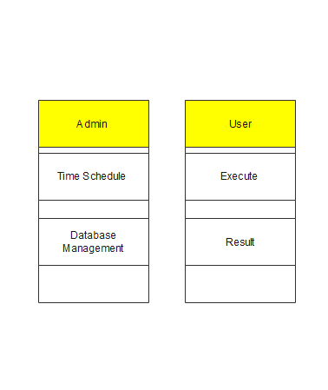

Fig. Class Diagram

## 4.3 Data Flow Diagram

A data flow diagram is graphical tool used to describe and analyses Movement of data through a system. These are the central tool and basis from which the other components are developed. The transformation of data from input to output, through processed, may be describe logically and independently of physical components associated with the system. These are known as the logical data flow diagrams. A full description of a system actually consists of a set of 0 data flow diagrams. The idea behind the explosion of process into greater detail at the next level. This is done until further explosion is necessary and an adequate amount of detail is described for analyst to understand the process. A DFD is also known as a “bubble chart” has the purpose of clarifying system requirements and identifying major transformation that will become programming system design. So it is the starting point of the design to the lowest level of detail. A DFD consist of a series of bubbles joined by flows in the system.

## DFD Symbols

In the DFD, there are four symbols

* + - A square defines a source (Originator) or destination of system data.
    - An arrow identifies data flow. It is the pipeline through which the information flows.
    - A circle or a bubble represents process that informs incoming data flow into outgoing data flows.
    - An open rectangle is a data store, data at rest or a temporary repository of data.

User

Remind Me

Figure 4.3.1 DFD Level 0

Admin

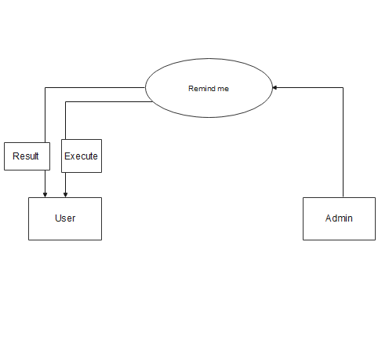

Figure 4.3.2 DFD Level 1

## Use Case Diagram

Use-Case is used to model the system from the point of view of end-user. Use Cases are created during requirements elicitation

Use Case helps in understanding exact product requirements in contexts of its operation clearly. The purpose of use case is as follows:

* + - Definition of functional and operational requirements of the product with the help of defining a scenario of usage that is agreed software engineer team and end-users.
* Providing clear and operational requirements of the product with the help of defining a scenario of usage that is agreed software engineer team and end-user.
* Provide basis for the purpose of validate testing.
* To start developing a set of use cases, the functions or the activities performed by actor are listed. The list of use-cases may be obtained from one of the following sources.

Digital Grampanchayat System

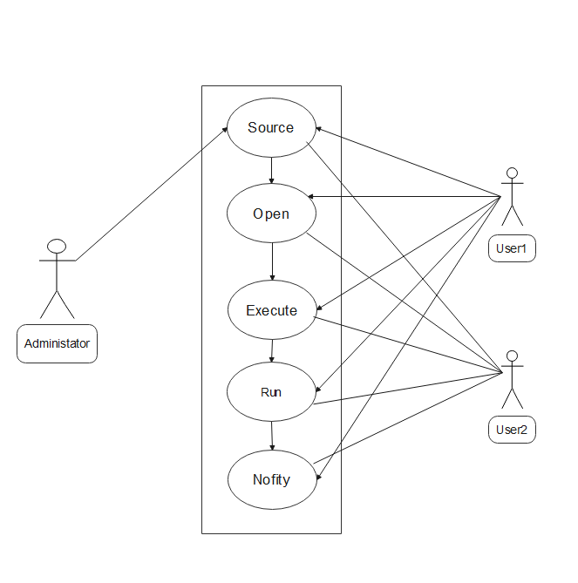

Figure 4.4 Use Case Diagram

## System Diagram

These diagrams are used to represent the behavior of the system these diagrams shows how events cause transition from object. Once the events are specified from the use cases, system diagrams can be created.

* + - System diagram is the most common kind of interaction diagram, which focuses on the message interchange between a numbers of lifelines.
    - System diagram describes an interaction by focusing on the sequence of messages that are exchanged, along with their corresponding occurrence specifications on the lifelines.

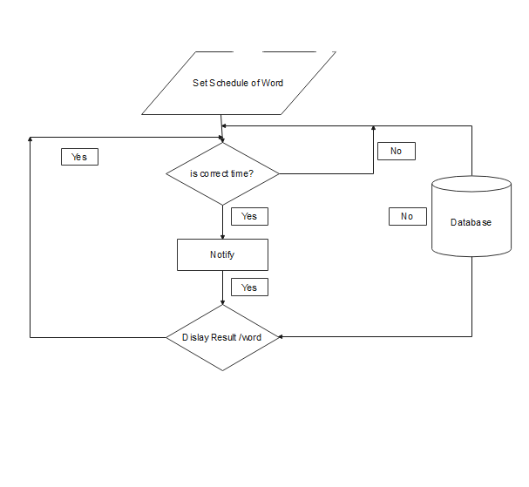

Fig: System Diagram

Chapter 5

***IMPLEMENTATION***

# MODULES

## ADMIN MODULE

## In this module first admin stores English word and their pronounciation also meaning in Marathi in XML(Extended Markup Language) file and make connectivity of that XML( Extended Markup Language) file to the python module Beautiful soup.

## Time module: This module is used to set perticular time between two words.

## Notifcation module: This module is use to send notification to the desktop pip (Preferred Installer Program) player.

## BeautifulSoup module: This module is use to make connectivity between XML(Extended Markup Language) file and python.

## Player: Player is used for creating notification on desktop.

## bs4: Beautiful Soup(bs4) is a Python library for pulling data out of HTML and XML files. To install this module type the below command in the terminal.

## And then admin send this source file to the user.

## USER MODULE:s

With the help of this module, user runs the source code and get notification on desktop.

# Software Environments

## Introduction to technology Used (i.e. Python)

Python is an [interpreted](https://en.wikipedia.org/wiki/Interpreted_language) [high-level](https://en.wikipedia.org/wiki/High-level_programming_language) [general-purpose programming language](https://en.wikipedia.org/wiki/General-purpose_programming_language). Python's design philosophy emphasizes [code readability](https://en.wikipedia.org/wiki/Code_readability) with its notable use of [significant indentation](https://en.wikipedia.org/wiki/Off-side_rule). Its [language constructs](https://en.wikipedia.org/wiki/Language_construct) as well as its [object-oriented](https://en.wikipedia.org/wiki/Object-oriented_programming) approach aim to help [programmers](https://en.wikipedia.org/wiki/Programmers) write clear, logical code for small and large-scale projects.

[Guido van Rossum](https://en.wikipedia.org/wiki/Guido_van_Rossum) began working on Python in the late 1980s, as a successor to the [ABC programming language](https://en.wikipedia.org/wiki/ABC_(programming_language)), and first released it in 1991 as Python 0.9.0. Python 2.0 was released in 2000 and introduced new features, such as [list comprehensions](https://en.wikipedia.org/wiki/List_comprehension) and a garbage collection system using [reference counting](https://en.wikipedia.org/wiki/Reference_counting). Python 3.0 was released in 2008 and was a major revision of the language that is not completely [backward-compatible](https://en.wikipedia.org/wiki/Backward_compatibility) and much Python 2 code does not run unmodified on Python 3. Python 2 was discontinued with version 2.7.18 in 2020

* **Simple:** It is very simple and easy to use, compare to other scripting language it is very simple and easy, this is widely used all over the world.
* **Interpreted:** It is an interpreted language, i.e. there is no need for compilation.
* **Faster:** It is faster than other scripting language e.g. xml and Python.

* **Open Source:** Open source means you no need to pay for use Python, you can free download and use.
* **Platform Independent:** Python code will be run on every platform, Linux, UNIX, Mac OS X, and Windows.
* **Case Sensitive:** Python is case sensitive scripting language at time of variable declaration. In Python, all keywords (e.g. if, else, while, echo, etc.), classes, functions, and user-defined functions are NOT case-sensitive.
* **Error Reporting:** Python have some predefined error reporting constants to generate a warning or error notice.
* **Real-Time Access Monitoring:** Python provides access logging by creating the summary of recent accesses for the user.
* **Loosely Typed Language:** Python supports variable usage without declaring its data type. It will be taken at the time of the execution based on the type of data it has on its value.

## Thonny

Thonny is an [integrated development environment](https://en.wikipedia.org/wiki/Integrated_development_environment) for [Python](https://en.wikipedia.org/wiki/Python_(programming_language)) that is designed for beginners. It supports different ways of stepping through the code, step-by-step expression evaluation, detailed visualization of the call stack and a mode for explaining the concepts of references and heap.

## XML Server

Extensible Markup Language (XML) is a [markup language](https://en.wikipedia.org/wiki/Markup_language) that defines a set of rules for encoding [documents](https://en.wikipedia.org/wiki/Electronic_document) in a [format](https://en.wikipedia.org/wiki/File_format) that is both [human-readable](https://en.wikipedia.org/wiki/Human-readable_medium) and [machine-readable](https://en.wikipedia.org/wiki/Machine-readable_data). The [World Wide Web Consortium](https://en.wikipedia.org/wiki/World_Wide_Web_Consortium)'s XML 1.0 Specification of 1998.and several other related specifications. All of them free [open standards](https://en.wikipedia.org/wiki/Open_standard) define XML.

The design goals of XML emphasize simplicity, generality, and usability across the [Internet](https://en.wikipedia.org/wiki/Internet). It is a textual data format with strong support via [Unicode](https://en.wikipedia.org/wiki/Unicode) for different [human languages](https://en.wikipedia.org/wiki/Language). Although the design of XML focuses on documents, the language is widely used for the representation of arbitrary [data structures](https://en.wikipedia.org/wiki/Data_structure) such as those used in [web services](https://en.wikipedia.org/wiki/Web_service).

Several [schema systems](https://en.wikipedia.org/wiki/XML_schema) exist to aid in the definition of XML-based languages, while programmers have developed many [application programming interfaces](https://en.wikipedia.org/wiki/Application_programming_interface) (APIs) to aid the processing of XML data.

## Types of Tests

We are using the following types of Testing Technologies in our project.

## Unit Testing

Unit testing involves the design of the test cases that validate that the internal program logic is functioning properly, and that program inputs produce valid outputs. All decision branches an internal code flow should be validated. It is the testing of individual software unit of the application. It is done after the completion of an individual unit before integration. This is structural testing, that relies on knowledge of its construction and invasive. Unit test performs basic test at component level and test a specific business process, application and/or system configuration. Unit test ensure that each unique path of a business process performs accurately to the documented specification and contains clearly defined inputs and expected results.

## Integration Testing

As the components are constructed and tested they are then linked together to check if they work with each other. It is a fact that two components that have passed all their tests, when connected to each other produce one new component full of faults. These tests can be done by specialists, or by the developers. Integration Testing is not focused on what the components are doing but on how they communicate with each other, as specified in the "System Design". The "System Design" defines relationships between components. The tests are organized to check all the interfaces, until all the components have been built and interfaced to each other producing the whole system.

## White Box Testing

White Box Testing is a testing in which the software tester has knowledge of the inner working, structure and language of the software, or at least its purpose. It is used to test areas that cannot be reached from a black box level.

## Black Box Testing

Black Box Testing is testing the software without any knowledge of the inner working structure or language of the module being tested. Black Box tests, as most other kinds of tests, must be written from a definitive source document, such as specification or requirements document, as such as specification or requirement document. It is a testing in which the software under test is treated, as black box. You cannot “see” into it.

The test provides inputs and responds to outputs without considering how the software works.

Chapter 6

***FLOW OF PROJECT***

* 1. **Home Page**

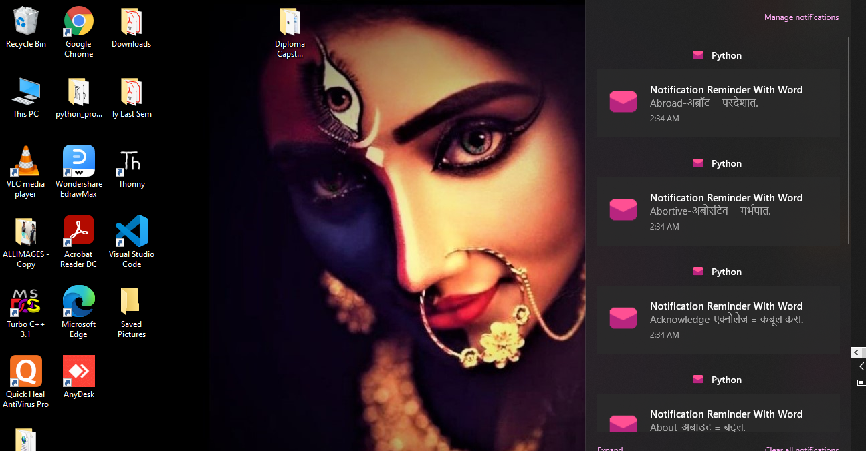

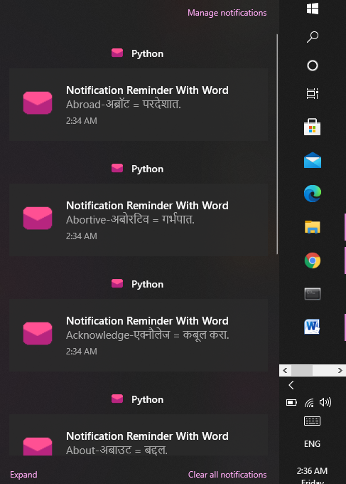

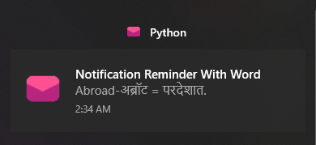

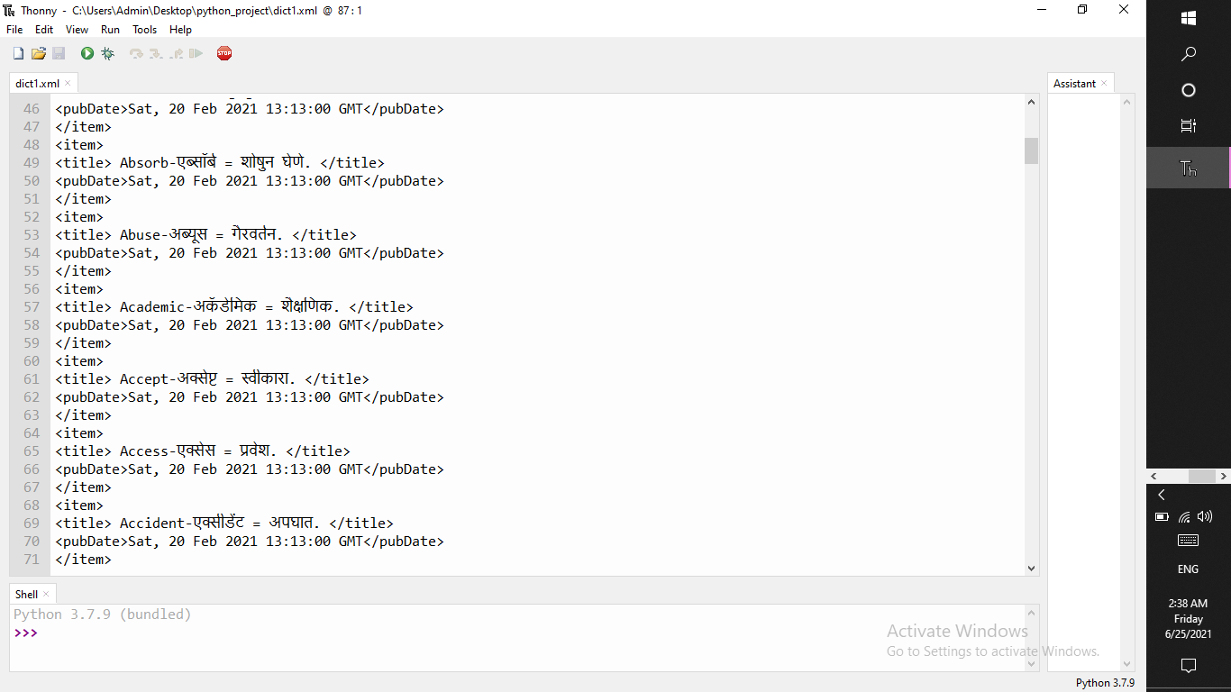

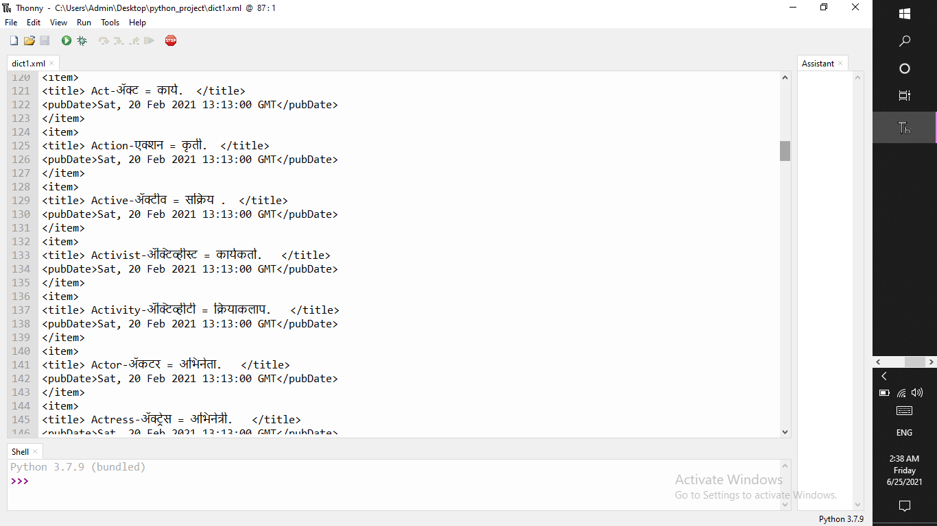

# CONCLUSION

* Our goal was to create an application where people learn new English word and improving knowledge.
* With the goals achieved the basis of application and this project has been achieved.
* Building this desktop application has been enriching because throughout the project we learnt lot about Python language.
* I hope this article had created interest in you to create your own customized desktop notification application. This application works for any kind of operating system be it Windows or Linux or Mac.

***REFERENCES***

# REFERANCES

* + Usability testing of mobile applications: A comparison between laboratory and field testing. Journal of Usability Studies, 1(1), 4–16. Kim, J., Park, Y., Kim, C. & Lee, H. (2014). Mobile application service networks: Apple’s app store. Service Business, 8(1), 1–27.
  + Krumm, J. C. & Hughes, R. L. (2006). U.S. Patent Application 11/462,885. Laurel, B. (2003). Design research: Methods and merspectives. LA: MIT Press. Leung, N., Nkhoma, M. & John, B. (2013). Proceedings of the 4th International Conference on IS
  + Management and Evaluation: ICIME 2013. UK: Academic Conferences Limited.

**Websites**

* + [www.w3schools.com](http://www.w3schools.com/)
  + [www.aspforums.com](http://www.aspforums.com/)
  + [www.way2tutorial.com](http://www.way2tutorial.com/)
  + [www.core.ac.uk](http://www.core.ac.uk/)



**Appendix**